**AIM:-Creation of database of student and faculty table.**

**Student (sid, sname, address, ph_no,DOB)**

**Faculty (fid, sid, fname, dept, DOJ)**

**DATABASE CREATION**

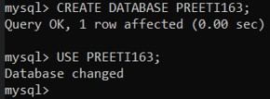

**STUDENT TABLE CREATION**

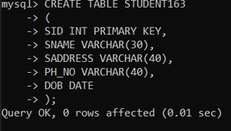

**VALUES INSERTION IN STUDENT TABLE**

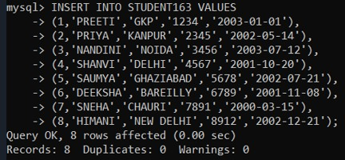

**STUDENT TABLE DISPLAY**

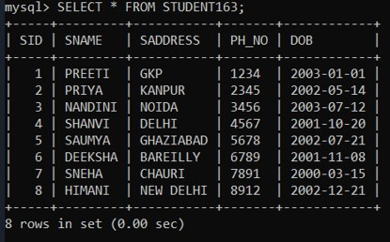

**STUDENT TABLE DESCRIPTION**

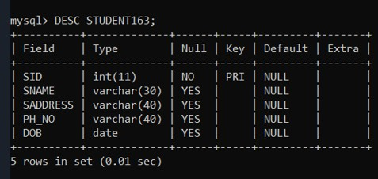

**FACULTY TABLE CREATION**

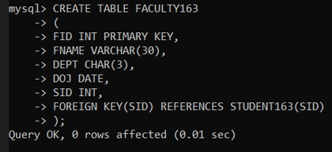

**VALUES INSERTION IN FACULTY TABLE**

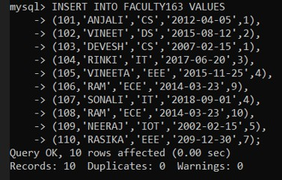

**FACULTY TABLE DISPLAY**

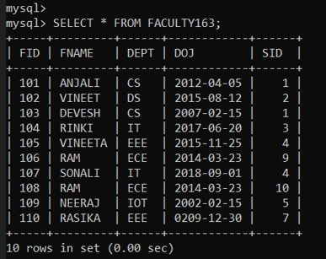

**FACULTY TABLE DESCRIPTION**

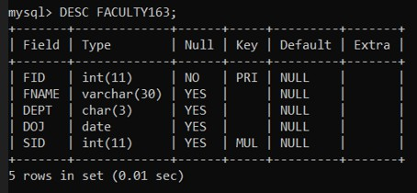

**To perform all the basic SQL Operations on Student and Faculty Table.**

**SELECT Statement:** The **SELECT** statement is used to select data from a database.

**SYNTAX:** SELECT column1, column2,....

FROM table_name;

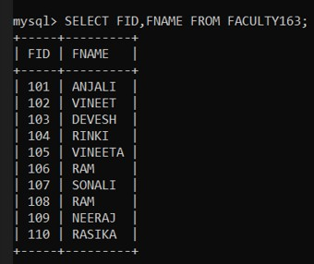

**DISTINCT Statement:** The **SELECT DISTINCT** statement is used to return only distinct (different) values.

**SYNTAX:** SELECT DISTINCT column1, column2,..

FROM table_name;

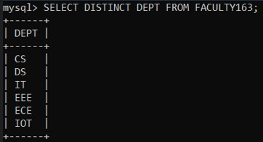

**WHERE Clause:**The **WHERE** clause is used to filter records.It is used to extract

that fulfill a specified condition.

**SYNTAX:** SELECT column1, column2, …

FROM table_name WHERE condition;

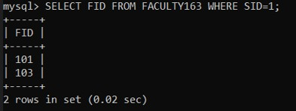

**AND Operator:**The **AND** operator displays a record if all the conditions separated by **AND** are TRUE.

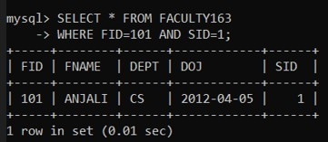**SYNTAX:** SELECT column1, column2, …FROM table_name WHERE condition1 AND condition2 AND condition3 …;

**OR Operator:** The **OR** operator displays a record if any of the conditions separated by **OR** is TRUE.

**SYNTAX:** SELECT column1, column2,.. FROM table_name WHERE condition1 OR condition2 OR condition3 ...;

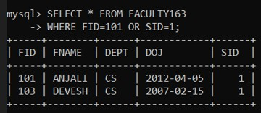

**NOT Operator:**The **NOT** operator displays a record if the condition(s) is NOT TRUE.

**SYNTAX:** SELECT column1, column2, …

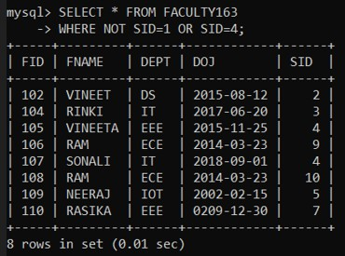FROM table_name WHERE NOT condition;

**ORDER BY KEYWORD:**The **ORDER BY** keyword is used to sort the result-set in ascending or descending order.

**SYNTAX:** SELECT column1, column2, … FROM table_name ORDER BY column1, column2, ... ASC|DESC;

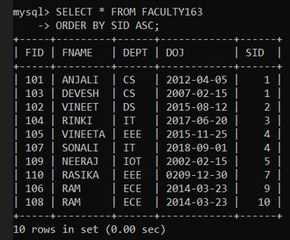

**INSERT INTO:**The **INSERT INTO** statement is used to insert new records in a table.

**SYNTAX:** INSERT INTO table_name

VALUES (value1, value2, value3, ...);

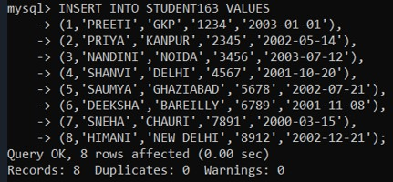

**NULL VALUES:**A field with a NULL value is a field with no value.

If a field in a table is optional, it is possible to insert a new record or update a record without adding a value to this field. Then, the field will be saved with a NULL value.

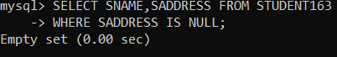**SYNTAX:** SELECT column_names FROM table_name WHERE column_name IS NULL;

**UPDATE Statement:**The **UPDATE** statement is used to modify the existing records in a table.

**SYNTAX:** UPDATE table_name

SET column1 = value1, column2 = value2, …

WHERE condition;

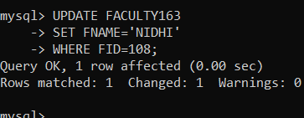

**MIN Function:**The **MIN()** function returns the smallest value of the selected column.

**SYNTAX:** SELECT MIN(column_name)

FROM table_name WHERE condition;

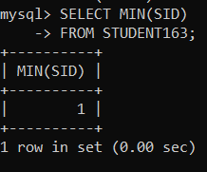

**MAX Function:**The **MAX()** function returns the largest value of the selected column.

**SYNTAX:** SELECT MAX(column_name)

FROM table_name WHERE condition;

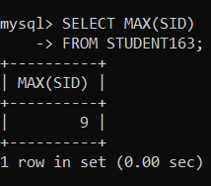

**COUNT() Function:**The **COUNT()** function returns the number of rows that matches a specified criterion.

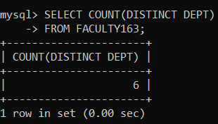**SYNTAX:** SELECT COUNT(column_name) FROM table_name WHERE condition;

**AVG() Function:**The **AVG()** function returns the average value of a numeric column.

**SYNTAX:** SELECT AVG(column_name)

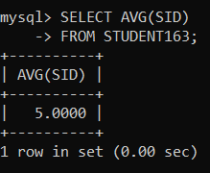FROM table_name WHERE condition;

**SUM() Function:**The **SUM()** function returns the total sum of a numeric column.

**SYNTAX:** SELECT SUM(column_name)

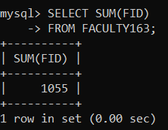FROM table_name WHERE condition;

**LIKE Operator:**The **LIKE** operator is used in a **WHERE** clause to search for a specified pattern in a column.The percent sign (%) represents zero, one, or multiple characters.

The underscore sign (_) represents one, single character.

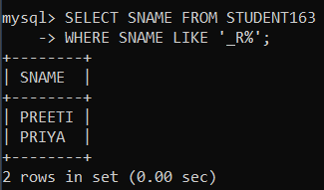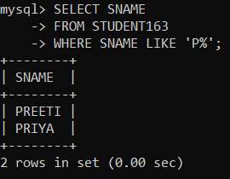**SYNTAX:** SELECT column1, column2,.. FROM table_name WHERE columnN LIKE pattern;

**DELETE Statement:**The **DELETE** statement is used to delete existing records in a table.

**SYNTAX:** DELETE FROM table_name

WHERE condition;

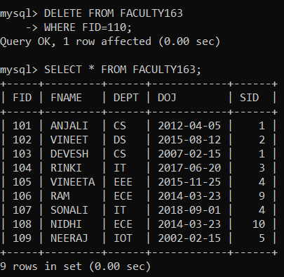

**IN Operator:**The IN operator allows you to specify multiple values in a WHERE clause.The IN operator is a shorthand for multiple OR conditions.

**SYNTAX:** SELECT column_name(s) FROM table_name WHERE column_name IN (value1, value2, ...);

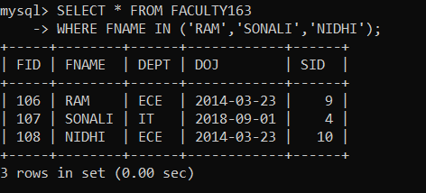

**BETWEEN Operator:**The BETWEEN operator selects values within a given range. The values can be numbers, text, or dates.

The BETWEEN operator is inclusive: begin and end values are included.

**SYNTAX:** SELECT column_name(s)

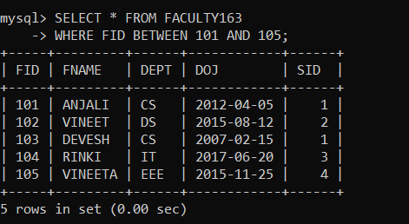FROM table_name WHERE column_name BETWEEN value1 AND value2;

**ALIASES:**Aliases are used to give a table, or a column in a table, a temporary name. An alias only exists for the duration of that query. An alias is created with the AS keyword.

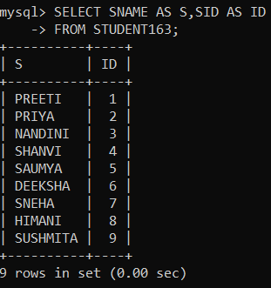**SYNTAX:** SELECT column_name AS alias_name FROM table_name;

**GROUP BY:**The GROUP BY statement groups rows that have the same values into summary rows. The GROUP BY statement is often used with aggregate functions (COUNT(), MAX(), MIN(), SUM(), AVG()) to group the result-set by one or more columns.

**SYNTAX:** SELECT column_name(s)

FROM table_name WHERE condition GROUP BY column_name(s)

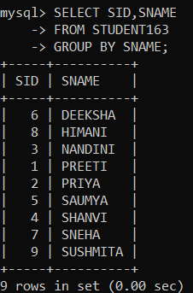ORDER BY column_name(s);

**HAVING Clause:**The HAVING clause was added to SQL because the WHERE keyword cannot be used with aggregate function.

**SYNTAX:** SELECT column_name(s) FROM table_name WHERE condition

GROUP BY column_name(s) HAVING condition

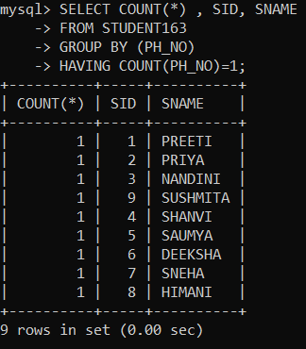ORDER BY column_name(s);

**UNION Operator:**The UNION operator is used to combine the result-set of two or more SELECT statements. Every SELECT statement within UNION must have the same number of columns The columns must also have similar data types.

**SYNTAX:**SELECT column_name(s) FROM table1 UNION

SELECT column_name(s) FROM table2;

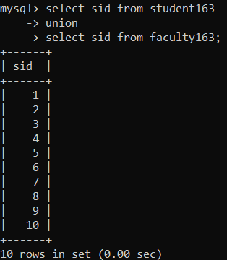

**EXISTS Operator:**

The EXISTS operator is used to test for the existence of any record in a subquery. The EXISTS operator returns TRUE if the subquery returns one or more records. **SYNTAX:**SELECT column_name(s)

FROM table_name WHERE EXISTS

(SELECT column_name FROM table_name WHERE condition);

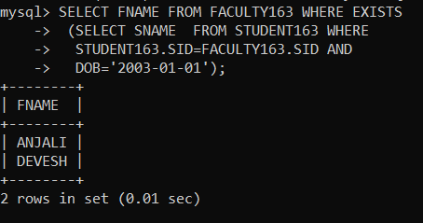

**ANY Operator:**The ANY operator:

**:-**returns a boolean value as a result

:-returns TRUE if ANY of the subquery values meet the condition

ANY means that the condition will be true if the operation is true for any of the values in the range.

**SYNTAX:**SELECT column_name(s) FROM table_name

WHERE column_name operator ANY (SELECT column_name

FROM table_name WHERE condition);

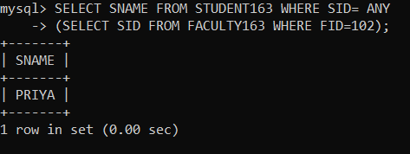

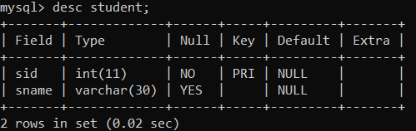**AIM:To perform join operation on database.**

**DATABASE CREATION:**



**CREATE TABLE (A):**

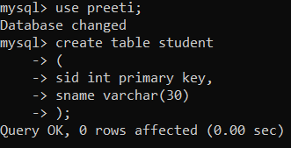

**INSERTION:**

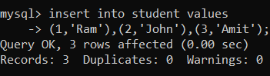

**DISPLAY:**

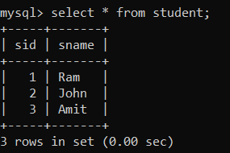

**DESCRIPTION:**

**CREATE TABLE (B):**

**CREATION**

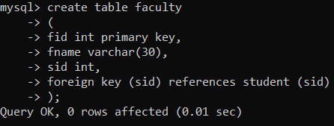

**INSERTION:**

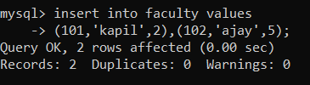

**DISPLAY**

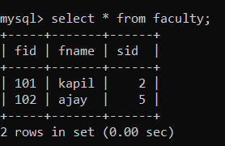

**DESCRIPTION**

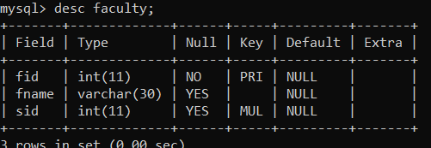

**JOINS:**A JOIN clause is used to combine rows from two or more tables, based on a related column between them.

1. 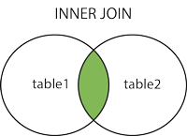**INNER JOIN:**The INNER JOIN keyword selects records that have matching values in both Table.

**SYNTAX:** SELECT column_name(s) FROM table1 INNER JOIN table2

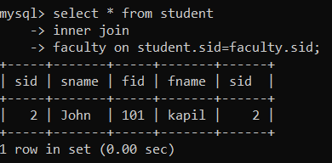ON table1.column_name = table2.column_name;

1. **LEFT JOIN:**The LEFT JOIN keyword returns all records from the left table (table1), and the matching records from the right table (table2).

The result is 0 records from the right side, if there is no match.

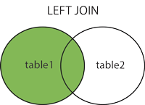

**SYNTAX:** SELECT column_name(s)

FROM table1 LEFT JOIN table2

ON table1.column_name = table2.column_name;

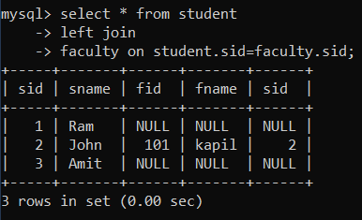

**RIGHT JOIN:**The **RIGHT JOIN** keyword returns all records from the right table (table2), and the matching records from the left table (table1).

The result is 0 records from the left side, if there is no match.

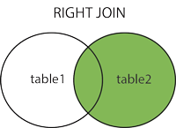

**SYNTAX:** SELECT column_name(s) FROM table1 RIGHT JOIN table2

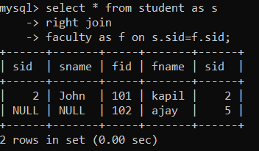ON table1.column_name = table2.column_name;

**EXPERIMENT- 05**